

***Operating Lease Support System Phase-2 Project***

***for***

****

***Functional Specification***

***FC.AB.2.1 Manage SKD***

Revision 0.0

**PT. Berlian Sistem Informasi**

KTB Annex Bld. 4th Floor, Jl. Jend. A. Yani. Pulomas,

Tel. +62 21 4786 7575 (Hunting) Fax. +62 21 4714964 www.bsi.co.id

Document Control

|  |  |
| --- | --- |
| **Author** | Raymond |
| **File Name** |  |
| **Path** |  |
| **Number of Page** |  |

Revision History

|  |  |  |  |
| --- | --- | --- | --- |
| **Date** | **Revision** | **Description** | **Author** |
| 1/10/2015 | 0.0 | Initialization | Raymond |
| 22/10/2015 | 0.1 | * Adding Functional Specification for List of Visit Customer Survey * Adding Functional Specification for Create Visit Customer Survey * Adding Functional Specification for Edit Visit Customer Survey * Adding Functional Specification for View Visit Customer Survey * Adding Functional Specification for Print Visit Customer Survey | Raymond |
| 22/10/2015 | 0.2 | * 1st Baseline | Raymond |
| 30/10/2015 | 0.3 | * Adding screen design for all Functions | Raymond |
| 13/10/2015 |  |  |  |

Distribution List

|  |  |  |
| --- | --- | --- |
| Name | Organization | Roles |
| Mr. Jin Nishimura | Dipo Star Finance, PT | DSF Project Director |
| Mr. Shinji Hosokawa | Dipo Star Finance, PT | DSF Project Advisor |
| Mr. Ahmad Fikri | Dipo Star Finance, PT | DSF Project Advisor |
| Mr. Abdul Somad | Dipo Star Finance, PT | DSF Project Manager |
| Mr. Delta Riangga | Dipo Star Finance, PT | DSF Key User |
| Mr. Mochamad Idris | Dipo Star Finance, PT | DSF Key User |
| Mrs. Herni Hembang | Dipo Star Finance, PT | DSF Key User |
| Mr. Junaidi Didy | Dipo Star Finance, PT | DSF Key User |
| Mr. Mukhlis Ibrahim | Dipo Star Finance, PT | DSF IT Department Representative |
| Mr. Roby Wijaya | Dipo Star Finance, PT | DSF IT Department Representative |
| Mr. Satoshi Koibuchi | Berlian Sistem Informasi, PT | BSI Project Director |
| Mr. Feri Irawan | Berlian Sistem Informasi, PT | BSI Project Advisor |
| Mr. Grand Zah Putra | Berlian Sistem Informasi, PT | BSI Project Manager |
| Mr. Raymond | Berlian Sistem Informasi, PT | BSI Business Analyst |

Document Approval

By signing this document I acknowledge I have read the document and give the Project Management Team approval to proceed.

|  |  |  |  |
| --- | --- | --- | --- |
| Role | Name | Signature | Date |
| DSF Project Director | Mr. Jin Nishimura |  |  |
| DSF Project Advisor | Mr. Ahmad Fikri |  |  |
| DSF Project Manager | Mr. Abdul Somad |  |  |
| DSF IT Department Representative | Mr. Mukhlis Ibrahim |  |  |
| BSI Project Director | Mr. Satoshi Koibuchi |  |  |
| BSI Project Advisor | Mr. Feri Irawan |  |  |
| BSI Project Manager | Mr. Grand Zah Putra |  |  |
| BSI Business Analyst | Mr. Raymond |  |  |

Table of Contents

Document Control 2

Revision History 2

Distribution List 3

Document Approval 4

1. Introduction 6

1.1 Purpose 6

1.2 Scope 6

1.3 Definition, Acronyms, and Abbreviations 6

1.4 References 6

2. Configuration 7

3. Detail Specification: FC.AB.2.1 Manage SKD 7

3.1. Purpose 7

3.2. Screen of Configuration Access 7

3.3. Screen Functionality 7

3.4. Operation Flow 8

3.5. Screen Design 8

3.6. Component Screen Functionality 13

3.7. Operation Description 19

3.8. Screen Item List 27

3.9. Data Structure 29

1. Introduction
   1. Purpose

Functional Specification is a document to describe the detail of functions system which includes screen design, report, and logic formula. This document will be used for system development.

* 1. Scope

Functional Specification Document contains screen design, screen functionality, process flow, and data structure of FC.AB.2.1 Manage SKD for Phase-2

Here are the scope for FC.AB.2.1 Manage SKD

1. **AB.2.1.3 Create SKD**

To create a SKD data

1. **AB.2.1.4 Edit SKD**

To edit a draft document of SKD

1. **AB.2.1.5 Submit SKD**

To submit SKD which will be approved by DSF Authorized Person

Output from this document is:

1. RPT.AB.2.1 SKD Form
2. PF.AB.2.1 SKD Report
   1. Definition, Acronyms, and Abbreviations
3. OPL = Operating Lease
4. DSF = Dipo Star Finance
5. BSI = Berlian Sistem Informasi
6. HOB = Head of Branch
7. HOD = Head of Department
8. RM = Regional Manager
9. SKD = Surat Keputusan Direksi/ Board of Director’s Decree
   1. References

This functional specification document refers to **“To Be Design” AB. Marketing Process**, module:

1. AB.2 SKD Process

* AB.2.1 SKD Creation of Operating Lease

1. Configuration

* N/A

1. Detail Specification: FC.AB.2.1 Manage SKD
   1. Purpose

The screens used in Manage SKD are used to Create, Edit, and Submit the SKD and generate an output as a print form of the SKD Form

* 1. Screen of Configuration Access

Here are the access right for users:

|  |  |  |  |  |
| --- | --- | --- | --- | --- |
| ***User*** | ***Create*** | ***Read*** | ***Update*** | **Authorization** |
| Marketing Officer | v | V | v | - |
| Head of Branch | - | V | - | v |
| Head of Department | - | V | - | v |
| Regional Manager | - | V | - | v |
| Advisor | - | V | - | v |
| Director | - | V | - | v |
| President Director | - | V | - | v |
| Shareholder’s Meeting | - | V | - | v |

* 1. Screen Functionality

1. Show lists of SKD record data
2. Create a SKD
3. Edit a draft document of SKD
4. View a SKD
5. Submit a SKD
6. Print a SKD Form
   1. Operation Flow

Below is operation flow for Monitoring and print unit preparation process refer to **To Be Design Document Marketing Process**, **AB.2.1 Board of Director’s Decree/ Surat Keputusan Direksi (SKD)**:

|  |  |
| --- | --- |
| **PIC PC** | **Process** |
|  | Quotation  (OPLQuotation)  D:\Users\bsi00815\Desktop\PrintScreen\SKD\SKD v3\SKD v4\SKD_Add.png  Supplier Master Data  (Supplier)    SKD  (Tb\_MKT\_SKD)  Note:  Source  Output & Input |

* 1. Screen Design
* *Initial Screen Manage SKD*

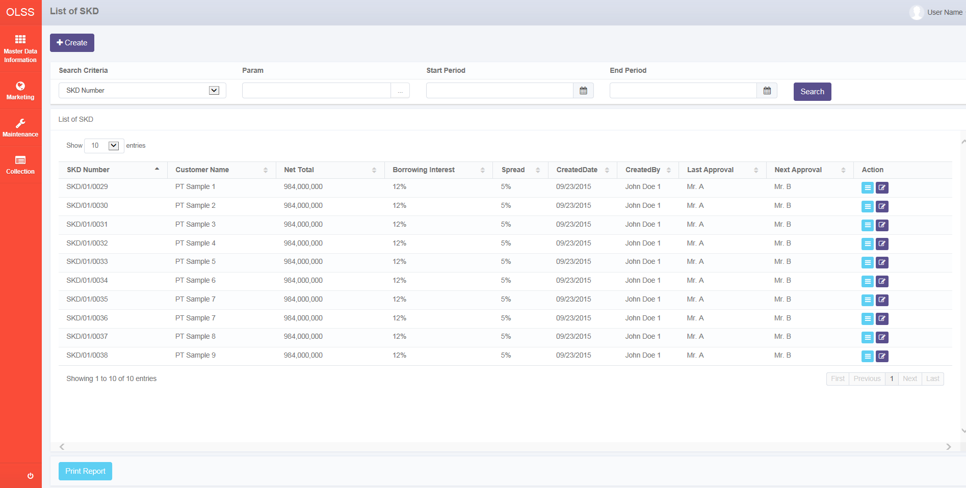

*Screen 1. List of SKD*

* *Create SKD*

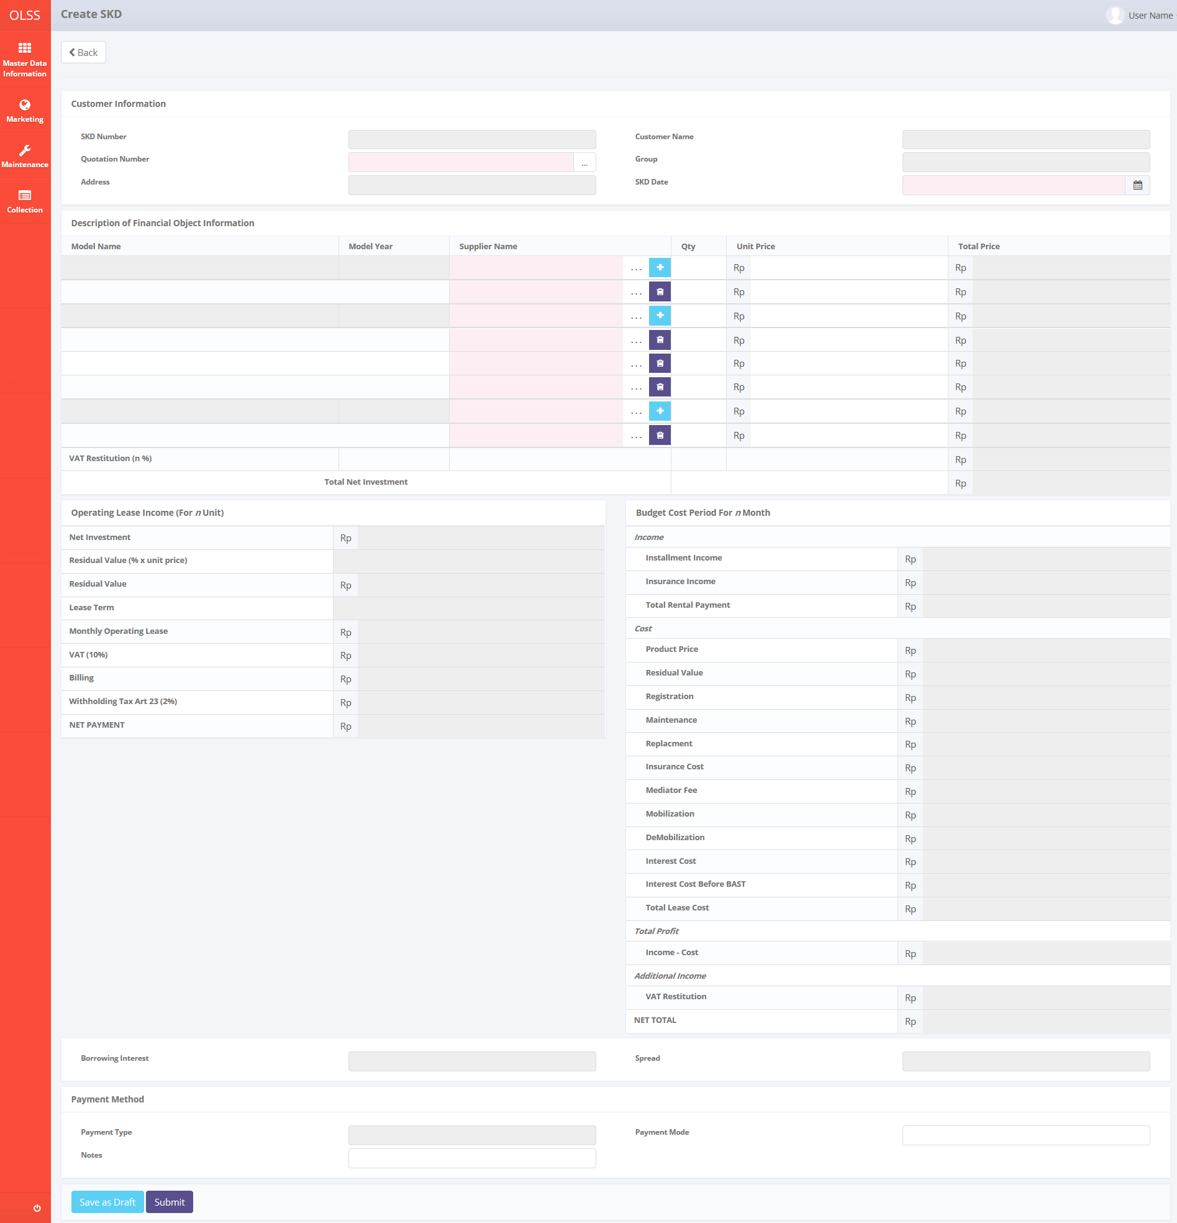

*Screen 2. Create SKD*

* *Edit SKD*

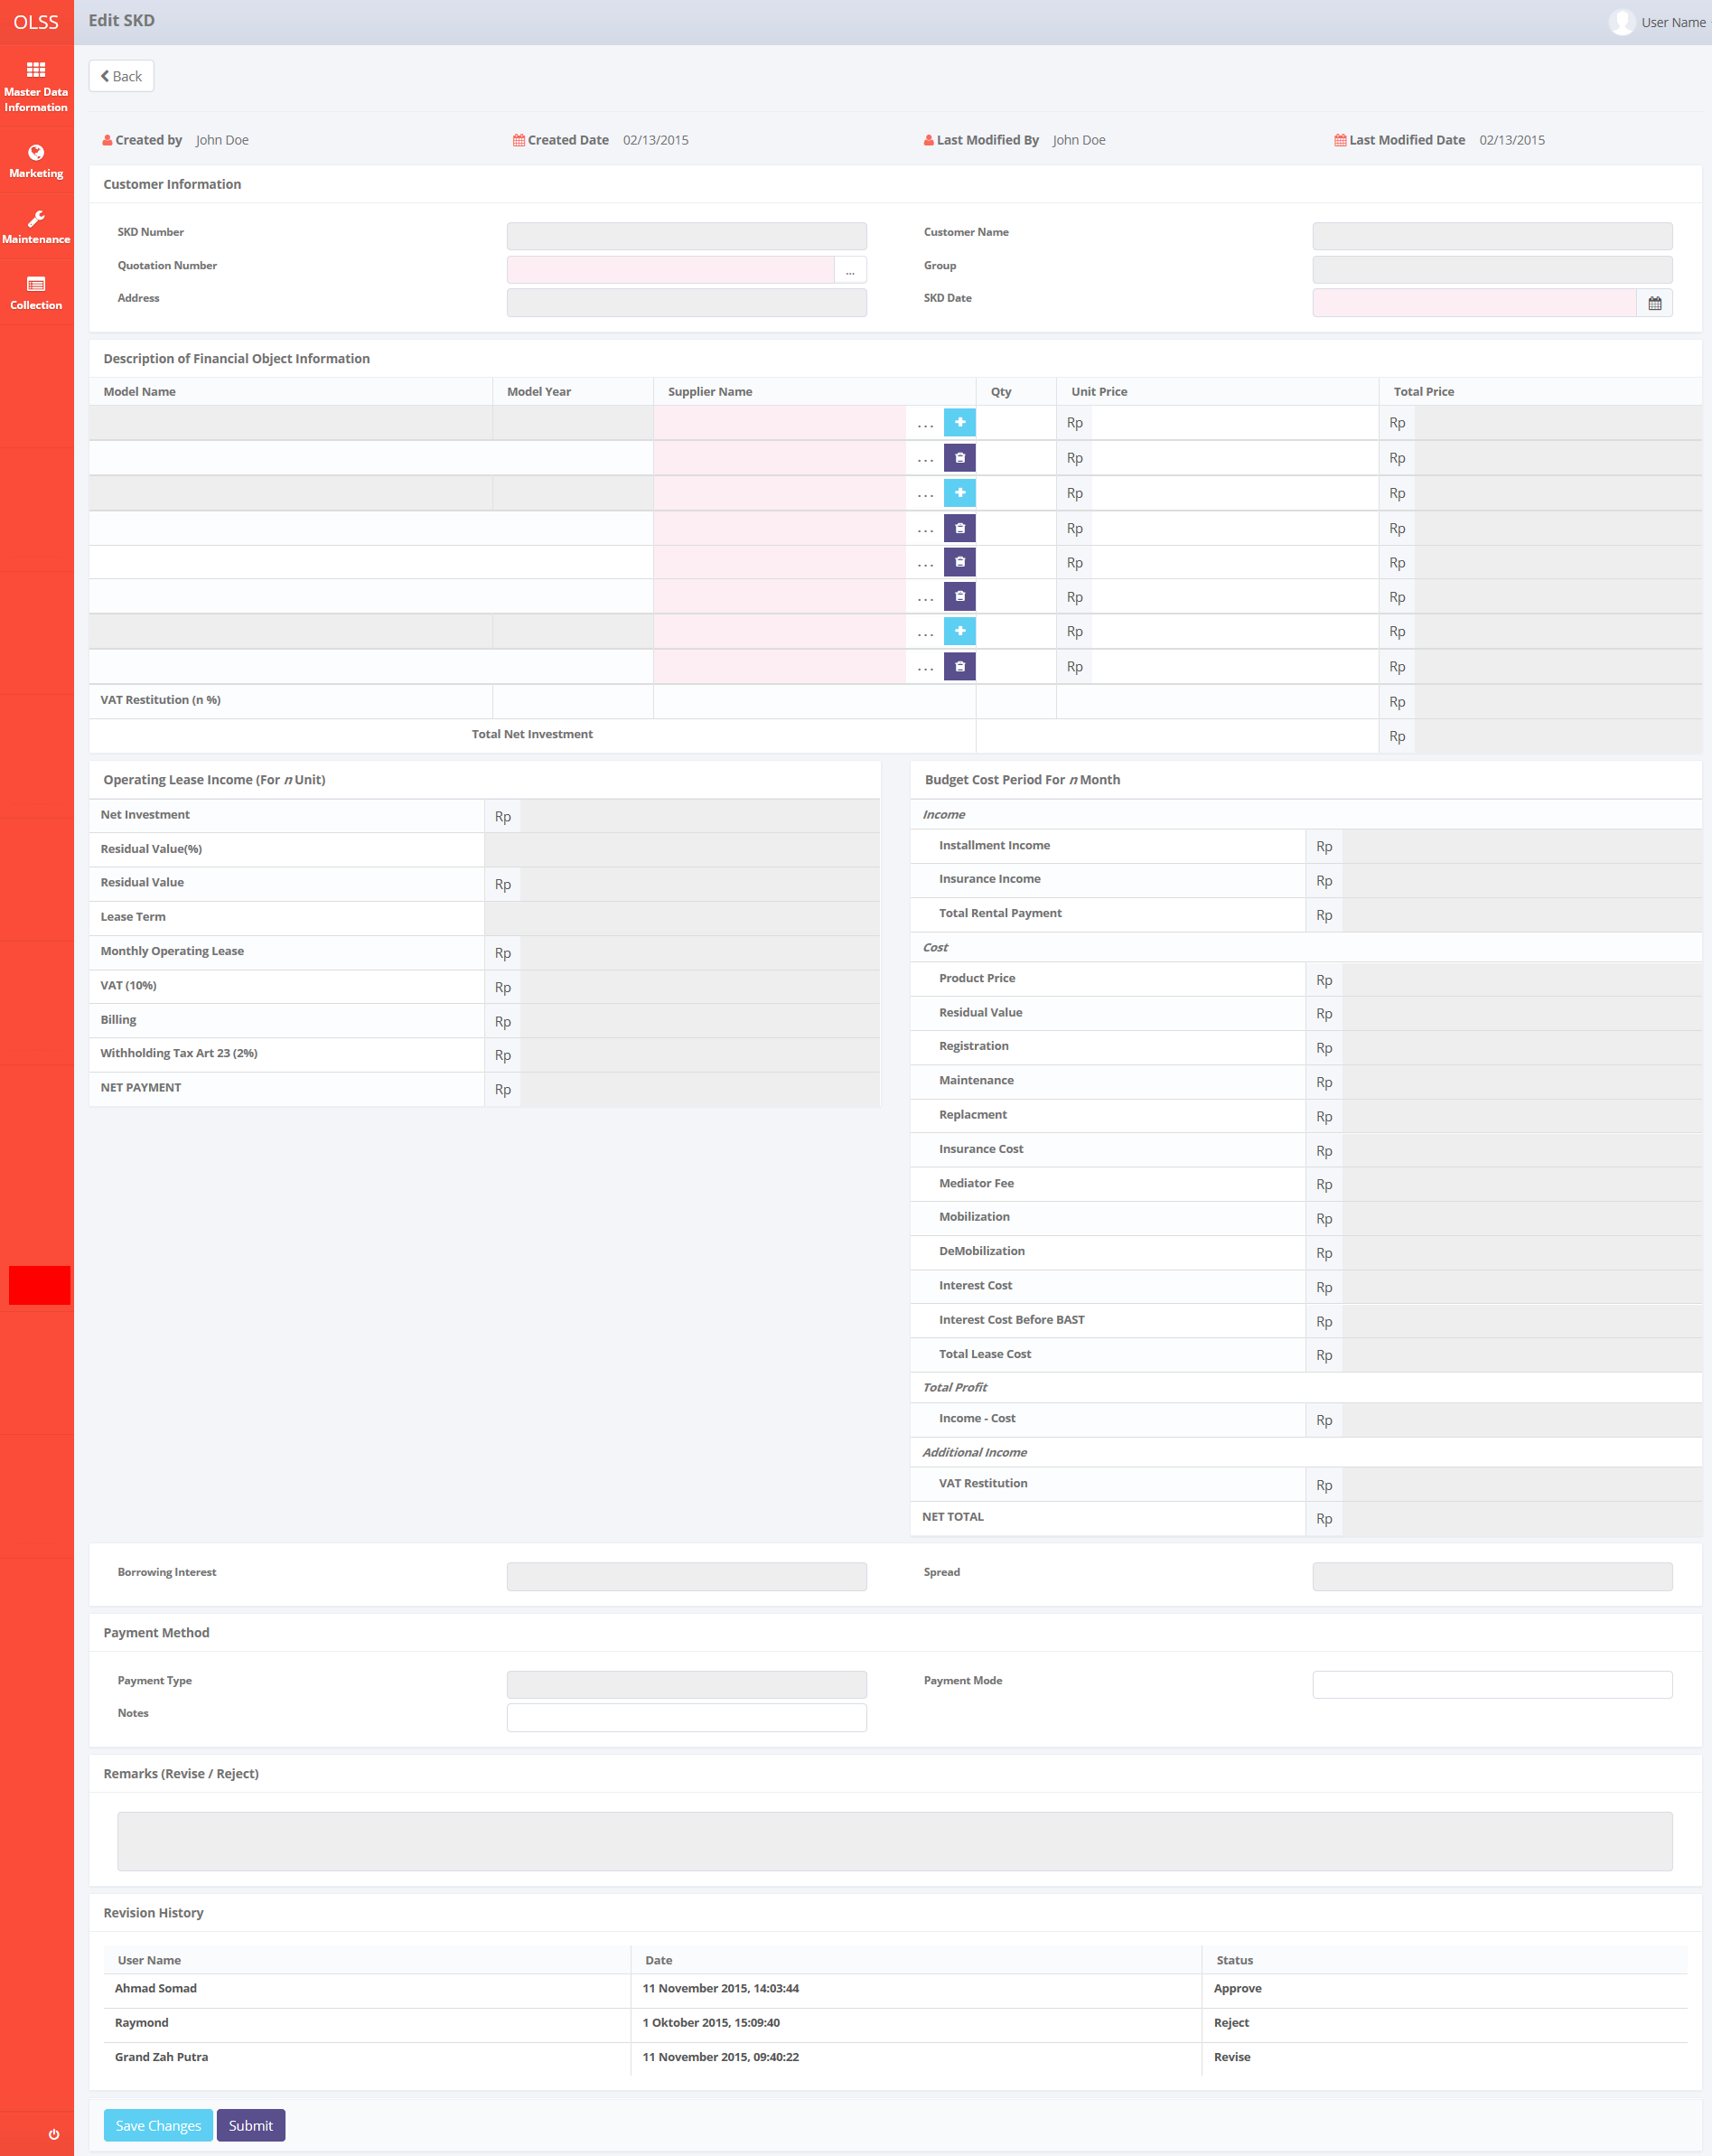

*Screen 3. Edit SKD*

* *View SKD*

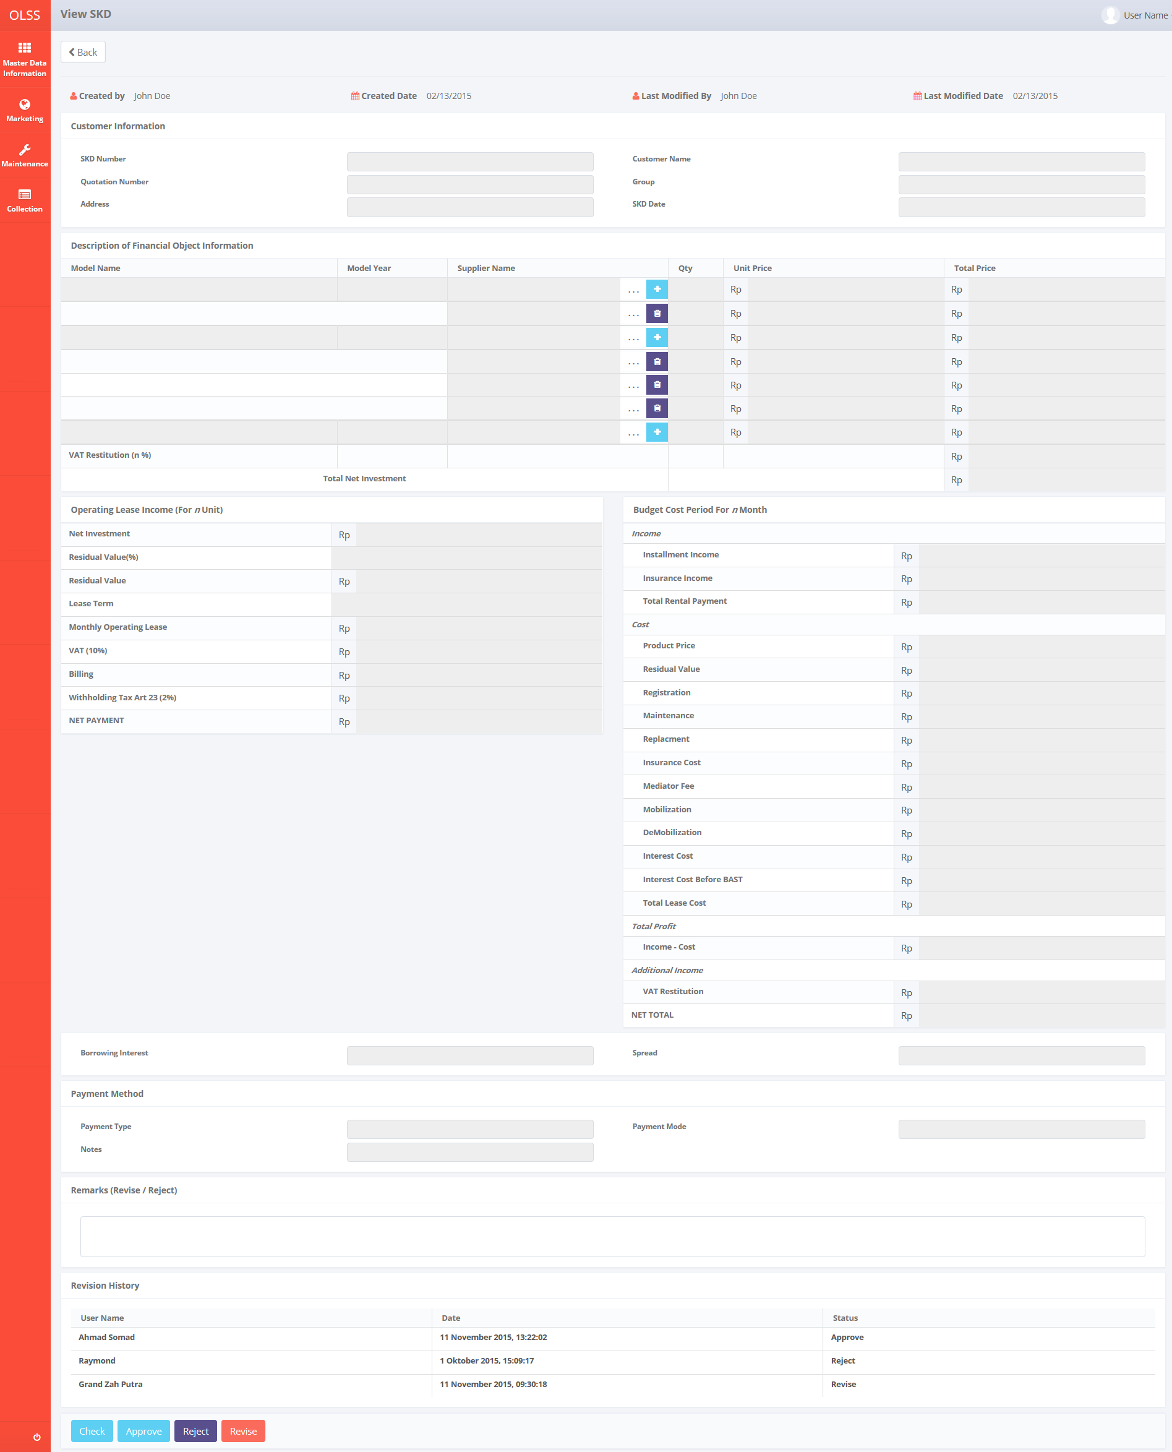

*Screen 4. View SKD*

* *Print Form SKD*

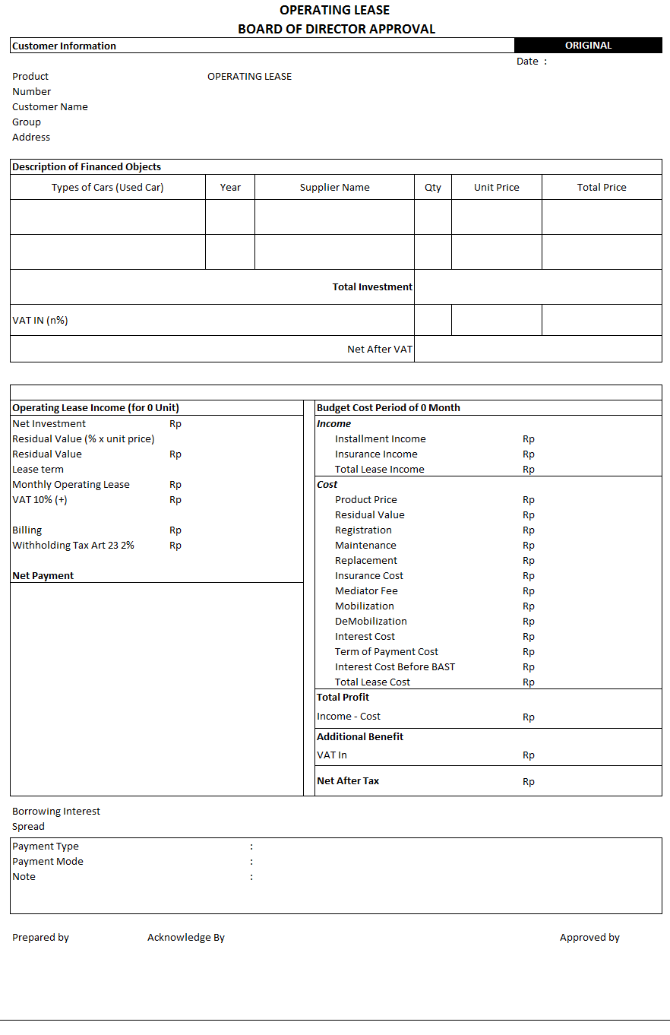

*Screen 5. Print Form SKD*

* *Print Report SKD*

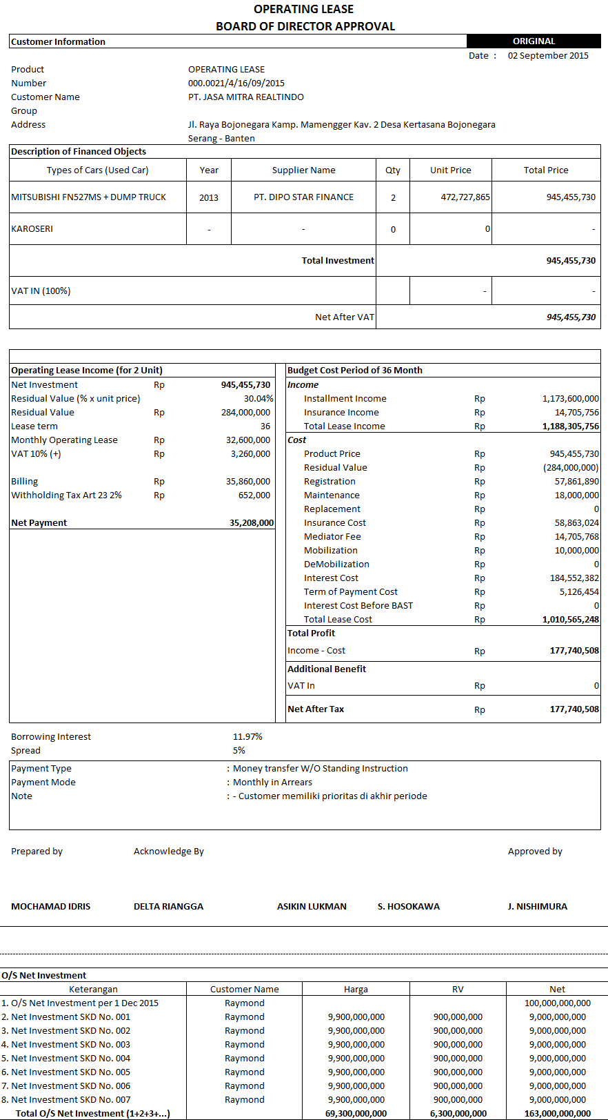

*Screen 6. Print Report SKD*

* *Notification after Save or Submit SKD*



*Screen 7. Save or Submit Notification*

* 1. Component Screen Functionality
  2. **List of Visit Customer Survey**

Here are the screen functions from each component in **Screen 1. List of SKD**:

|  |  |  |  |
| --- | --- | --- | --- |
| ***No*** | ***Component*** | ***Name*** | ***Function*** |
| **Header** | | | |
| 1 | Label | List of SKD | SKD Creation title |
| 2 | Button | Create SKD | To select the operation for searching |
| **Search Criteria** | | | |
| 3 | Drop down box | Search criteria | To select the category for searching criteria |
| 4 | Text box/ Date picker | Parameter | To input the value for searching criteria |
| 5 | Date picker | Start Period | To select the start date of record lists |
| 6 | Date picker | End Period | To select the end date of record lists |
| 7 | Button | Search | To do a search and showing lists according to criteria |
| **List of SKD** | | | |
| 8 | Button | Edit SKD | To show an editable screen of Visit Customer Survey draft which has been created |
| 9 | Button | View SKD | To show details of Visit Customer Survey |
| 10 | Button | Print Form SKD | To show a preview of Visit Customer Survey report document before print |
| 11 | Drop down box | Entries | To show entry number of lists |
| 12 | Label | Customer Name | Display Customer Name of SKD that has been created |
| 13 | Button | Customer Name | To sort in ascending or descending format |
| 14 | Label | SKD Number | Display SKD Number that has been created |
| 15 | Button | SKD Number | To sort in ascending or descending format |
| 16 | Label | Net Total | Display Net Total of a SKD |
| 17 | Button | Net Total | To sort in ascending or descending format |
| 18 | Label | Borrowing Interest | Display Borrowing Interest of a SKD |
| 19 | Button | Borrowing Interest | To sort in ascending or descending format |
| 20 | Label | Created By | Display Created By of a SKD |
| 21 | Button | Created By | To sort in ascending or descending format |
| 22 | Label | Created Date | Display Created Date of a SKD |
| 23 | Button | Created Date | To sort in ascending or descending format |
| 24 | Label | Spread | Display Status of Visit Customer Survey that has been created |
| 25 | Button | Spread | To sort in ascending or descending format |
| 26 | Label | Last Approval | Display Last Approval of a SKD |
| 27 | Button | Last Approval | To sort in ascending or descending format |
| 28 | Label | Next Approval | Display Next Approval of a SKD |
| 29 | Button | Next Approval | To sort in ascending or descending format |
| 30 | Label | Action | Display Edit, View, and Report button |
| 31 | Label | Showing 1 to *n* of *n* entries | Display the entries generated by search engine |
| 32 | Link | First Page | To show the first page entry |
| 33 | Link | Previous Page | To show the previous page entry |
| 34 | Link | Page Number | To show the page screen according the number |
| 35 | Link | Next Page | To show the next page entry |
| 36 | Link | Last Page | To show the last page entry |
| **Footer** | | | |
| 37 | Button | Print Report | To print the report from the lists of record |

* 1. **Create SKD**

Here are the screen functions from each component in **Screen 2. Create SKD**:

|  |  |  |  |
| --- | --- | --- | --- |
| ***No*** | ***Component*** | ***Name*** | ***Function*** |
| **Customer Information** | | | |
| 1 | Text Box | SKD Number | Displaying SKD Number created |
| 2 | Searching Box | Quotation Number | To generate searching screen for Quotation No |
| 3 | Text Box | Address | To input Address value |
| 4 | Text Box | Customer Name | To input Customer Name value |
| 5 | Text Box | Group | To input Group value |
| 6 | Date Picker | SKD Date | To input SKD created date value |
| **Description of Financial Object Information** | | | |
| 7 | Text Box | Model Name | Displaying Model Name |
| 8 | Text Box | Model Year | Displaying Model Year |
| 9 | Searching Box | Supplier Name | To generate searching screen for Supplier Name |
|  | Button | Add | To add a row of supplier for an item |
|  | Button | Remove | To remove a row of supplier for an item |
| 10 | Text Box | Qty | Displaying Qty |
| 11 | Text Box | Unit Price | Displaying Unit Price |
| 12 | Text Box | Total Price | Displaying Total Price |
| 13 | Text Box | Delivery Fee | Displaying Delivery Fee |
| 14 | Text Box | Total Net Investment | Displaying Total Net Investment |
| **Operating Lease Income (For n Unit)** | | | |
| 15 | Text Box | Net Investment | Displaying Net Investment |
| 16 | Text Box | Residual Value(%) | Displaying Residual Value(%) |
| 17 | Text Box | Residual Value(Rp) | Displaying Residual Value(Rp) |
| 18 | Text Box | Lease Term | Displaying Lease Term |
| 19 | Text Box | Monthly Operating Lease | Displaying Monthly Operating Lease |
| 20 | Text Box | VAT (10%) | Displaying VAT (10%) |
| 21 | Text Box | Billing | Displaying Billing |
| 22 | Text Box | Witholding Tax Art 23 (10%) | Displaying Witholding Tax Art 23 (10%) |
| 23 | Text Box | NET PAYMENT | Displaying NET PAYMENT |
| **Budget Cost Period For n Month** | | | |
| 24 | Label | Income | Displaying Income field |
| 25 | Text Box | Total Rental Payment | Displaying Total Rental Payment |
| 26 | Label | Expense | Displaying Budget Cost Period For n Month field |
| 27 | Text Box | Interest | Displaying Interest |
| 28 | Text Box | Registration Value | Displaying Registration Value |
| 29 | Text Box | Insurance Premi | Displaying Insurance Premi |
| 30 | Text Box | Polis Insurance | Displaying Polis Insurance |
| 31 | Text Box | Mediator Fee | Displaying Mediator Fee |
| 32 | Text Box | Maintenance | Displaying Maintenance |
| 33 | Text Box | Accessories Expense | Displaying Accessories Expense |
| 34 | Text Box | Gain Value | Displaying Gain Value |
| 35 | Text Box | Total Expense | Displaying Total Expense |
| 36 | Label | Total Profit | Displaying Total Profit field |
| 37 | Text Box | (Total Income - Total Expense) | Displaying (Total Income - Total Expense) |
| **Footer** | | | |
| 38 | Text Box | Borrowing Interest | Displaying Borrowing Interest |
| 39 | Text Box | Spread | Displaying Spread |
| 40 | Label | Payment Method | Displaying Payment Method field |
| 41 | Text Box | Payment Type | Displaying Payment Type |
| 42 | Text Box | Payment Mode | Displaying Payment Mode |
| 43 | Text Box | Notes | Displaying Notes |
| 44 | Label | Revision Log | Displaying revision log |
| 45 | Button | Save as Draft | To save information that has been inserted at SKD form as a draft |
| 46 | Button | Submit | To submit information that has been inserted at SKD form to the next level |

* 1. **Edit SKD**

Here are the screen functions from each component in **Screen 3. Edit SKD**:

*See Component Screen Specification - b. Create SKD with addition of these components :*

|  |  |  |  |
| --- | --- | --- | --- |
| ***No*** | ***Component*** | ***Name*** | ***Function*** |
| **Header** | | | |
| 1 | Label | Edit SKD | Edit SKD title |
| 2 | Label | Created By | Displaying Created By |
| 3 | Label | Created Date | Displaying Created Date |
| 4 | Label | Last Modified By | Displaying Last Modified By |
| 5 | Label | Last Modified Date | Displaying Last Modified Date |
| **Revision History** | | | |
| 6 | Label | Revision History | Revision History sub-title |
| 7 | Label | User Name | Displaying User Name |
| 8 | Label | Date | Displaying Date |
| 9 | Label | Status | Displaying Status |
| **Footer** | | | |
| 10 | Text Area | Remarks (Reject/ Revise) | Displaying remarks from rejection/ revision |
| 11 | Button | Save Changes | To save the inputted form as draft document |

*and also these components are not available in Edit SKD :*

|  |  |  |  |
| --- | --- | --- | --- |
| ***No*** | ***Component*** | ***Name*** | ***Function*** |
| **Header** | | | |
| 1 | Label | Create SKD | Create SKD title |
| **Footer** | | | |
| 2 | Button | Save as Draft | To save the inputted form as draft document |

* 1. **View SKD**

Here are the screen functions from each component in **Screen 4. View SKD**:

*See Component Screen Specification - b. Create SKD with addition of these components :*

|  |  |  |  |
| --- | --- | --- | --- |
| ***No*** | ***Component*** | ***Name*** | ***Function*** |
| **Header** | | | |
| 1 | Label | View SKD | View SKD title |
| 2 | Label | Created By | Displaying Created By |
| 3 | Label | Created Date | Displaying Created Date |
| 4 | Label | Last Modified By | Displaying Last Modified By |
| 5 | Label | Last Modified Date | Displaying Last Modified Date |
| **Revision History** | | | |
| 6 | Label | Revision History | Revision History sub-title |
| 7 | Label | User Name | Displaying User Name |
| 8 | Label | Date | Displaying Date |
| 9 | Label | Status | Displaying Status |
| **Footer** | | | |
| 10 | Text Area | Remarks (Reject/ Revise) | To input remarks of revision or rejection |
| 11 | Button | Check | To check a SKD |
| 12 | Button | Approve | To approve a SKD |
| 13 | Button | Reject | To reject a SKD |
| 14 | Button | Revise | To revise a SKD |

*and also these components are not available in View SKD :*

|  |  |  |  |
| --- | --- | --- | --- |
| ***No*** | ***Component*** | ***Name*** | ***Function*** |
| **Header** | | | |
| 1 | Label | Create SKD | Create SKD title |
| **Footer** | | | |
| 2 | Button | Save as Draft | To save the inputted form as draft document |
| 3 | Button | Submit | To submit the inputted form |

* 1. **Print Form SKD**

Here are the screen functions from each component in **Screen 5. Print Form SKD**:

|  |  |  |  |
| --- | --- | --- | --- |
| ***No*** | ***Component*** | ***Name*** | ***Function*** |
| **Header** | | | |
| 1 | Label | Print SKD | Print SKD title |
| 2 | Button | Back | Back to previous screen |
| 3 | Button | Print | To print the previewed document |
| 4 | Link | First Page | To show the first page |
| 5 | Link | Previous Page | To show the previous page |
| 6 | Text box | Page Number | To show the page screen according to the number |
| 7 | Link | Next Page | To show the next page |
| 8 | Link | Last Page | To show the last page |
| 9 | Text box | Search field | To input the keyword to be searched in the form page |
| 10 | Link | Find | To find the keyword in the search field |
| 11 | Link | Next | To move to the nect keyword found on the form page |
| 12 | Drop down box | Convert to excel/ pdf | To convert the document into excel/ pdf |
| 13 | Button | Refresh | To refresh the page |
| **Body page** | | | |
| 14 | Image preview | SKD Form | Displaying the preview of document |

* 1. Operation Description

|  |  |  |
| --- | --- | --- |
| **No.** | **Operation Name** | **Description** |
| 1 | Initial view of List of SKD | The screen for list of SKD:   1. Component Status;  |  |  |  |  | | --- | --- | --- | --- | | Component | Name/Caption | Status | Remark | | Drop down box | User Name | Active |  | | Label | List of SKD | Not Active |  | | Check box | Search criteria selection | Active |  | | Drop down box | Search criteria category | Active |  | | Text box | Search criteria value | Active |  | | Button | Add | Active |  | | Button | Remove | Active |  | | Button | Search | Active |  | | Button | Create SKD | Active |  | | Button | Edit SKD | Active |  | | Button | View SKD | Active |  | | Button | Print Report SKD | Active |  | | Label | SKD Number | Not Active |  | | Label | Customer Name | Not Active |  | | Label | Product Type | Not Active |  | | Label | Supplier Name | Not Active |  | | Label | Qty | Not Active |  | | Label | Net Total | Not Active |  | | Label | Borrowing Interest | Not Active |  | | Label | Spread | Not Active |  | | Label | Created Date | Not Active |  | | Label | Created By | Not Active |  | | Label | Status | Not Active |  | | Label | Action | Not Active |  | | Button | First Page | Active | Active depending on the current entry | | Button | Previous Page | Active | Active depending on the current entry | | Link | Page Number | Active | Active depending on the current entry | | Button | Next Page | Active | Active depending on the current entry | | Button | Last Page | Active | Active depending on the current entry | |
| 2 | Searching the List of SKD | Input:   1. Select searching criteria category (search criteria), searching criteria value (parameter), Start Period (Visit Date), and End Period (Visit Date) in the Search Field   D:\Users\bsi00815\AppData\Local\Microsoft\Windows\Temporary Internet Files\Content.Word\VCS_List.png  Constraint:   1. Search criteria only consists of SKD Number, Customer Name, Net Total, Borrowing Interest, Spread, Last Approval, and Nect Approval (the same as the lists) generated from Tb\_OPL\_SearchCriteria mapping 2. End Period can not be less than Start Period (the End Period will be locked for the date before Start Date) 3. Start Period can not be less than End Period (the Start Period will be locked for the date after End Date) 4. Click on the Search button   D:\Users\bsi00815\AppData\Local\Microsoft\Windows\Temporary Internet Files\Content.Word\Visit Customer Survey Report.png   1. The screen will view the list of SKD according to criteria 2. Select number of show list entries: 10, 25, 50, and 100 and click the page for viewing more data.   Process:   1. After clicking the search button, the system will get the data from Tb\_MKT\_SKD table and OPLCalculation table to be displayed in the list   Output:   1. Display list data of SKD   **NB:The approval status can be monitored by seeing the last approval and next approval column. User with his/her name attached in last approval column is the latest person to approve and user with his/her name attached in next approval column is the next person to approve the document.** |
| 3 | Initial view of Create SKD | The screen for Create SKD:   1. Status component;  |  |  |  |  | | --- | --- | --- | --- | | Component | Name/Caption | Status | Remark | | Label | Customer Information | Not Active |  | | Text Box | SKD Number | Not Active |  | | Searching Box | Quotation Number | Active | Mandatory field depicted in red text box | | Text Box | Address | Not Active |  | | Text Box | Customer Name | Not Active |  | | Text Box | Group | Not Active |  | | Date Picker | SKD Date | Active | Mandatory field depicted in red text box | | Label | Description of Financial Object Information | Not Active |  | | Text Box | Model Name | Not Active |  | | Text Box | Model Year | Not Active |  | | Searching Box | Supplier Name | Active | Mandatory field depicted in red text box | | Button | Add | Active |  | | Button | Remove | Active |  | | Text Box | Qty | Active |  | | Text Box | Unit Price | Not Active |  | | Text Box | Total Price | Not Active |  | | Text Box | Delivery Fee | Not Active |  | | Text Box | Total Net Investment | Not Active |  | | Label | Operating Lease Income (For n Unit) | Not Active |  | | Text Box | Net Investment | Not Active |  | | Text Box | Residual Value(%) | Not Active |  | | Text Box | Residual Value(Rp) | Not Active |  | | Text Box | Lease Term | Not Active |  | | Text Box | Monthly Operating Lease | Not Active |  | | Text Box | VAT (10%) | Not Active |  | | Text Box | Billing | Not Active |  | | Text Box | Withholding Tax Art 23 (10%) | Not Active |  | | Text Box | NET PAYMENT | Not Active |  | | Label | Budget Cost Period For n Month | Not Active |  | | Label | Income | Not Active |  | | Text Box | Total Rental Payment | Not Active |  | | Label | Expense | Not Active |  | | Text Box | Interest | Not Active |  | | Text Box | Registration Value | Not Active |  | | Text Box | Insurance Premi | Not Active |  | | Text Box | Polis Insurance | Not Active |  | | Text Box | Mediator Fee | Not Active |  | | Text Box | Maintenance | Not Active |  | | Text Box | Accessories Expense | Not Active |  | | Text Box | Gain Value | Not Active |  | | Text Box | Total Expense | Not Active |  | | Label | Total Profit | Not Active |  | | Text Box | (Total Income - Total Expense) | Not Active |  | | Text Box | Borrowing Interest | Not Active |  | | Text Box | Spread | Not Active |  | | Label | Payment Method | Not Active |  | | Text Box | Payment Type | Not Active |  | | Text Box | Payment Mode | Not Active |  | | Text Box | Notes | Active |  | | Button | Save as Draft | Active |  | | Button | Submit | Active |  | |
| 4 | Create SKD | Input   1. Click the button Create SKD on the List of SKD screen      1. Input the following field:  * Quotation No * SKD Date * Supplier Name * New/Used * Qty * O/S Investment   Constraints:   1. Inputting Qty will trigger a hint to input the field with only number 2. Hint “24 hours format” will appear if the user clicked onto the field SKD Date 3. Every field inputted cannot exceed maximum length defined in database system 4. If there are cases which require multiple supplier to provide the item, it is possible to add a row of the unit (accessories and carroserrie will follow the number of row) and define the qty needed for the supplier to provide. 5. From step 2, click on Save as Draft button to save the document in draft status   D:\Users\bsi00815\AppData\Local\Microsoft\Windows\Temporary Internet Files\Content.Word\VCS_Create.png  Constraint:   1. If clicked with any of the field still hasn’t meet the validation criteria, every notification message for validation below the field will be generated (notification “This field is required” for mandatory field) 2. Clicking the button will trigger a pop up screen for validation “**Are you sure you want to Save?**” 3. From step 2, click on Submit button to submit the document for next process and change the status of document into Submitted   D:\Users\bsi00815\AppData\Local\Microsoft\Windows\Temporary Internet Files\Content.Word\VCS_Edit.png  Constraint:   1. If clicked with any of the field still hasn’t meet the validation criteria, every notification message for validation below the field will be generated 2. Clicking the button will trigger a pop up screen for validation “**Are you sure you want to Submit?**”   Process   1. Inputting Quotation No will get data for all Entity (except SKD Date, Supplier Name, Quantity, and Notes) from Tb\_MKT\_OPLCalculation 2. Qty of Accessories and Carroserrie as part of item attached to unit will follow the qty of the unit itself 3. Revision Log will be inserted with the User Name, Date, and Status of the last activity into Tb\_MKT\_SKDLog   Status consists of:   * Update (when button Save as Draft or Save Changes is clicked) * Submit (when button Submit is clicked) * Check (when button Check is clicked) * Approve (when button Approve is clicked) * Reject (when button Reject is clicked) * Revise (when button Revise is clicked)   Output:   1. By clicking save as draft or submit, the inputted data will be inserted into Tb\_MKT\_SKD table and generate SKD Number with a notification “**Success!** SKD Number : xxxx has been saved” (xxxx refers to Tb\_MKT\_SKD.SKDNo)   Altenative:   1. From step 1, click on Back button to go back to previous menu (List of SKD) |
| 5 | Initial view of Edit SKD | The screen for Edit SKD:   1. Status component;  |  |  |  |  | | --- | --- | --- | --- | | Component | Name/Caption | Status | Remark | | Drop down box | User Name | Active |  | | Label | Edit SKD | Not Active |  | | Button | Back | Active |  | | Label | Created By | Not Active |  | | Label | Created Date | Not Active |  | | Label | Last Modified By | Not Active |  | | Label | Last modified Date | Not Active |  | | Label | Customer Information | Not Active |  | | Text Box | SKD Number | Not Active |  | | Searching Box | Quotation Number | Active | Mandatory field depicted in red | | Text Box | Address | Not Active |  | | Text Box | Customer Name | Not Active |  | | Text Box | Group | Not Active |  | | Date Picker | SKD Date | Active | Mandatory field depicted in red | | Label | Description of Financial Object Information | Not Active |  | | Text Box | Model Name | Not Active |  | | Text Box | Model Year | Not Active |  | | Searching Box | Supplier Name | Active | Mandatory field depicted in red | | Text Box | Qty | Not Active |  | | Text Box | Unit Price | Not Active |  | | Text Box | Total Price | Not Active |  | | Text Box | Delivery Fee | Not Active |  | | Text Box | Total Net Investment | Not Active |  | | Label | Operating Lease Income (For n Unit) | Not Active |  | | Text Box | Net Investment | Not Active |  | | Text Box | Residual Value(%) | Not Active |  | | Text Box | Residual Value(Rp) | Not Active |  | | Text Box | Lease Term | Not Active |  | | Text Box | Monthly Operating Lease | Not Active |  | | Text Box | VAT (10%) | Not Active |  | | Text Box | Billing | Not Active |  | | Text Box | Witholding Tax Art 23 (10%) | Not Active |  | | Text Box | NET PAYMENT | Not Active |  | | Label | Budget Cost Period For n Month | Not Active |  | | Label | Income | Not Active |  | | Text Box | Total Rental Payment | Not Active |  | | Label | Expense | Not Active |  | | Text Box | Interest | Not Active |  | | Text Box | Registration Value | Not Active |  | | Text Box | Insurance Premi | Not Active |  | | Text Box | Polis Insurance | Not Active |  | | Text Box | Mediator Fee | Not Active |  | | Text Box | Maintenance | Not Active |  | | Text Box | Accessories Expense | Not Active |  | | Text Box | Gain Value | Not Active |  | | Text Box | Total Expense | Not Active |  | | Label | Total Profit | Not Active |  | | Text Box | (Total Income - Total Expense) | Not Active |  | | Text Box | Borrowing Interest | Not Active |  | | Text Box | Spread | Not Active |  | | Label | Payment Method | Not Active |  | | Text Box | Payment Type | Not Active |  | | Text Box | Payment Mode | Not Active |  | | Text Box | Notes | Active |  | | Button | Save Changes | Active |  | | Button | Submit | Active |  | |
| 6 | Edit SKD | Input:   1. Click the button Edit SKD on the List of SKD screen   D:\Users\bsi00815\Desktop\PrintScreen\Edit button.png   1. Update the following field (if needed):  * Quotation No * SKD Date * Supplier Name * Qty   Constraints:   1. Inputting Qty will trigger a hint to input the field with only number 2. Every field inputted cannot exceed maximum length defined in database system 3. From step 2, click on Save as Draft button to save the document in draft status   D:\Users\bsi00815\AppData\Local\Microsoft\Windows\Temporary Internet Files\Content.Word\VCS_Edit.png  Constraint:   1. If clicked with any of the field still hasn’t meet the validation criteria, every notification message for validation below the field will be generated (notification “This field is required” for mandatory field) 2. Clicking the button will trigger a pop up screen for validation “**Are you sure you want to Save?**” 3. From step 2, click on Submit button to submit the document for next process and change the status of document into Submitted   D:\Users\bsi00815\AppData\Local\Microsoft\Windows\Temporary Internet Files\Content.Word\VCS_Edit.png  Constraint:   1. If clicked with any of the field still hasn’t meet the validation criteria, every notification message for validation below the field will be generated 2. Clicking the button will trigger a pop up screen for validation “**Are you sure you want to Submit?**”   Process   1. Inputting Quotation No will get data for all Entity (except SKD Date, Supplier Name, Quantity, and Notes) from Tb\_MKT\_OPLCalculation 2. Qty of Accessories and Carroserrie as part of item attached to unit will follow the qty of the unit itself 3. Revision Log will be inserted with the User Name, Date, and Status of the last activity into Tb\_MKT\_SKDLog. The latest log will be displayed in the first row of Revision Log table in the View SKD screen   Status consists of:   * Update (when button Save as Draft or Save Changes is clicked) * Submit (when button Submit is clicked) * Check (when button Check is clicked) * Approve (when button Approve is clicked) * Reject (when button Reject is clicked) * Revise (when button Revise is clicked)   Output:   1. By clicking save changes or submit, the inputted data will update the Tb\_MKT\_SKD table.   Altenative:   1. From step 1, click on Back button to go back to previous menu (List of SKD) |
| 7 | Initial view of View SKD | The screen for View SKD:   1. Status component;  |  |  |  |  | | --- | --- | --- | --- | | Component | Name/Caption | Status | Remark | | Label | View SKD | Not Active |  | | Button | Back | Active |  | | Label | Created By | Not Active |  | | Label | Created Date | Not Active |  | | Label | Last Modified By | Not Active |  | | Label | Last modified Date | Not Active |  | | Label | Customer Information | Not Active |  | | Text Box | SKD Number | Not Active |  | | Searching Box | Quotation Number | Not Active |  | | Text Box | Address | Not Active |  | | Text Box | Customer Name | Not Active |  | | Text Box | Group | Not Active |  | | Date Picker | SKD Date | Not Active |  | | Label | Description of Financial Object Information | Not Active |  | | Text Box | Model Name | Not Active |  | | Text Box | Model Year | Not Active |  | | Searching Box | Supplier Name | Not Active |  | | Text Box | Qty | Not Active |  | | Text Box | Unit Price | Not Active |  | | Text Box | Total Price | Not Active |  | | Text Box | Delivery Fee | Not Active |  | | Text Box | Total Net Investment | Not Active |  | | Label | Operating Lease Income (For n Unit) | Not Active |  | | Text Box | Net Investment | Not Active |  | | Text Box | Residual Value(%) | Not Active |  | | Text Box | Residual Value(Rp) | Not Active |  | | Text Box | Lease Term | Not Active |  | | Text Box | Monthly Operating Lease | Not Active |  | | Text Box | VAT (10%) | Not Active |  | | Text Box | Billing | Not Active |  | | Text Box | Witholding Tax Art 23 (10%) | Not Active |  | | Text Box | NET PAYMENT | Not Active |  | | Label | Budget Cost Period For n Month | Not Active |  | | Label | Income | Not Active |  | | Text Box | Total Rental Payment | Not Active |  | | Label | Expense | Not Active |  | | Text Box | Interest | Not Active |  | | Text Box | Registration Value | Not Active |  | | Text Box | Insurance Premi | Not Active |  | | Text Box | Polis Insurance | Not Active |  | | Text Box | Mediator Fee | Not Active |  | | Text Box | Maintenance | Not Active |  | | Text Box | Accessories Expense | Not Active |  | | Text Box | Gain Value | Not Active |  | | Text Box | Total Expense | Not Active |  | | Label | Total Profit | Not Active |  | | Text Box | (Total Income - Total Expense) | Not Active |  | | Text Box | Borrowing Interest | Not Active |  | | Text Box | Spread | Not Active |  | | Label | Payment Method | Not Active |  | | Text Box | Payment Type | Not Active |  | | Text Box | Payment Mode | Not Active |  | | Text Box | Notes | Not Active |  | | Text Area | Remarks (Reject/Revise) | Active |  | | Button | Approve | Active |  | | Button | Reject | Active |  | | Button | Revise | Active |  | |
| 8 | View SKD | Input:   1. Click the button View SKD on the List of SKD screen   D:\Users\bsi00815\AppData\Local\Microsoft\Windows\Temporary Internet Files\Content.Word\Customer_Visit_Survey_List.png  Process:   1. The data on the View screen are extracted from Customer, Product, Supplier, OPLCalculation, OPLFinanceCondition, OPLInsuranceCondition, OPLBasicCondition, and Tb\_MKT\_SKD table 2. Revision Log will be inserted with the User Name, Date, and Status of the last activity into Tb\_MKT\_SKDLog. The latest log will be displayed in the first row of Revision Log table in the View SKD screen   Status consists of:   * Update (when button Save as Draft or Save Changes is clicked) * Submit (when button Submit is clicked) * Check (when button Check is clicked) * Approve (when button Approve is clicked) * Reject (when button Reject is clicked) * Revise (when button Revise is clicked)   Output:   1. The screen displays the Data from Customer, Product, Supplier, OPLCalculation, OPLFinanceCondition, OPLInsuranceCondition, OPLBasicCondition, Tb\_MKT\_SKD, and Tb\_MKT\_SKDLog   Altenative:   1. From step 1, click on Back button to go back to previous menu (List of SKD) |
| 9 | Initial screen on Print Form SKD | The screen for Print SKD:   1. Status component;  |  |  |  |  | | --- | --- | --- | --- | | Component | Name/Caption | Status | Remark | | Button | Back | Active |  | | Link | First Page | Active |  | | Link | Previous Page | Active |  | | Link | Page Number | Active |  | | Link | Next Page | Active |  | | Link | Last Page | Active |  | | Text box | Search | Active |  | | Link | Find | Active |  | | Link | Next | Active |  | | Button | Refresh | Active |  | | Drop down box | Convert to excel/ pdf | Active |  | |
| 10 | Convert Print preview to excel/ PDF | Input:   1. Click the button Print Form Visit Customer Survey on the List of Visit Customer Survey screen   D:\Users\bsi00815\AppData\Local\Microsoft\Windows\Temporary Internet Files\Content.Word\VCS_List.png  Process:   1. The data on the View screen are extracted from Supplier, Product, and Tb\_MKT\_VisitCustSurvey table   Output:   1. Print out Form **PF.AB.2.1 SKD Form**   Altenative:   1. From step 1, click on Back button to go back to previous menu (List of Visit Customer Survey) 2. Convert to excel/ pdf with the drop down button and the output will follow the predefined design |
| 11 | Print SKD list report | Input:   1. *Operation Name 4. Create SKD* 2. Click button Print Report     Process:  *-*  Output:   1. Print out report list **RPT.AB.2.1 SKD Form** |
| 14 | System error message | Process:   1. Any errors outside of application validation or that which cannot be handled by application such as errors when communicating with database, bugs, overloop, etc will generate an error message “System error. Please contact your administrator”   Output:   1. A page with system error message will appear. |

* 1. Screen Item List

**RPT.AB.2.1 SKD Report**

|  |  |  |  |  |
| --- | --- | --- | --- | --- |
| *No.* | *Content* | *Description* | *Source* | *Remarks* |
| 1 | SKD Number | SKD Number | Tb\_MKT\_SKD.SKDNo |  |
| 2 | Customer Name | Customer Name | Customer.CustomerName | *Where*  *Tb\_MKT\_SKD.IdCustomer = Customer.IdCustomer* |
| 3 | Net Total | Net Total | OPLCalculation.  NetTotal | *Where*  *Tb\_MKT\_SKD.IdOPLQuotation = OPLQuotation. IdOPLQuotation*  *And*  *OPLCalculation.IdOPLCalculation = OPLQuotation. IdOPLCalculation* |
| 4 | Borrowing Interest | Borrowing Interest | OPLCalculation.BorrowingInterest | *Where*  *Tb\_MKT\_SKD.IdOPLQuotation = OPLQuotation. IdOPLQuotation*  *And*  *OPLCalculation.IdOPLCalculation = OPLQuotation. IdOPLCalculation* |
| 5 | Spread | Spread | OPLCalculation.  Spread | *Where*  *Tb\_MKT\_SKD.IdOPLQuotation = OPLQuotation. IdOPLQuotation*  *And*  *OPLCalculation.IdOPLCalculation = OPLQuotation. IdOPLCalculation* |
| 6 | Last Approval | Last Approval | Tb\_MKT\_SKD.LastApproval | *Where Tb\_PRO\_PODtl.IdProduct = Product.IdProduct* |
| 7 | Next Approval | Next Approval | Tb\_MKT\_SKD.NextApproval | *Where Tb\_PRO\_PO.IdOPLAgreement = OPLAgreement.IdOPLAgreement* |

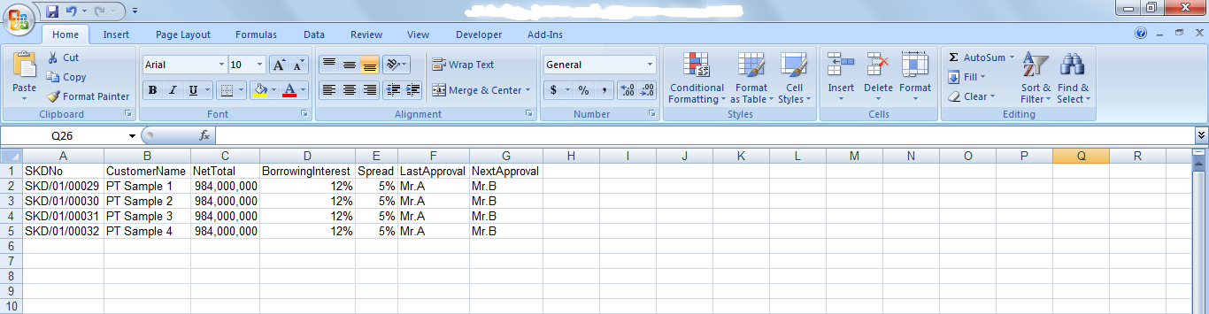

2

7

6

5

4

3

1

**PF.AB.2.1 SKD Form**

|  |  |  |  |  |
| --- | --- | --- | --- | --- |
| *No.* | *Content* | *Description* | *Source* | *Remarks* |
| 1 | Form Title | OPERATING LEASE BOARD OF DIRECTOR APPROVAL |  |  |
| 2 | Product | Operating Lease |  |  |
| 3 | Number | SKD Number | Tb\_MKT\_SKD.SKD Number |  |
| 4 | Customer Name | Customer Name | Customer.CustomerName |  |
| 5 | Group | Group | Customer.Group |  |
| 6 | Address | Address | Customer.Address |  |
| 7 | Date | SKD Date | Tb\_MKT\_SKD.SKDDate |  |
| 8 | Type of Cars | Model Name Unit | ProductModel.ModelName |  |
| 9 | Accessories/Carroserrie | Model Name Accessories/Carroserrie | Tb\_MKT\_SKD\_Dtl.Name |  |
| 10 | Year | Model Year | ProductModel.ModelYear |  |
| 11 | Supplier Name | Supplier Name | Supplier.SupplierName |  |
| 12 | Qty | Qty | Tb\_MKT\_SKD\_Dtl.Qty |  |
|  | Unit Price | Unit Price Unit | OPLBasicCondition.ProductPrice | *Where*  *Tb\_MKT\_SKD.IdOPLQuotation = OPLQuotation.IdOPLQuotation*  *And*  *OPLBasicCondition.IdOPLCalculation = OPLQuotation.IdOPLCalculation* |
|  | Unit Price | Unit Price Accessories/Carroserrie | Tb\_MKT\_SKD\_Dtl.Name |  |
| 13 | Total Price Unit | Total Price Unit |  | *Qty x Unit Price Unit* |
|  | Total Price Accessories/Carrosserie | Total Price Unit |  | *Qty x Unit Price Accessories/ Carrosserie* |
| 14 | Total Investment | Total Investment |  |  |
| 15 | VAT IN (%) | VAT IN |  |  |
| 16 | Net After VAT | Net After VAT |  |  |
| 17 | *n* unit | Qty |  |  |
| 18 | Net Investment | Net Investment |  |  |
| 19 | Residual Value (% x unit price) | Residual Value (%) |  |  |
| 20 | Residual Value | Residual Value |  |  |
| 21 | Lease term | Lease Term |  |  |
| 22 | Monthly Operating Lease | Monthly Operating Lease |  |  |
| 23 | VAT 10% (+) | VAT 10% (+) |  |  |
| 24 | Billing | Billing |  |  |
| 25 | Witholding Tac Art 23 2% | Witholding Tac Art 23 2% |  |  |
| 26 | Net Payment | Net Payment |  |  |
| 27 | *n* month | *n* month |  |  |
| 28 | Installment Income | Installment Income |  |  |
| 29 | Insurance Income | Insurance Income |  |  |
| 30 | Total Lease Income | Total Lease Income |  |  |
| 31 | Product Price | Product Price |  |  |
| 32 | Residual Value | Residual Value |  |  |
| 33 | Registration | Registration |  |  |
| 34 | Maintenance | Maintenance |  |  |
| 35 | Replacement | Replacement |  |  |
| 36 | Insurance Cost | Insurance Cost |  |  |
| 37 | Mediator Fee | Mediator Fee |  |  |
| 38 | Mobilization | Mobilization |  |  |
| 39 | DeMobilization | DeMobilization |  |  |
| 40 | Interest Cost | Interest Cost |  |  |
| 41 | Term of Payment Cost | Term of Payment Cost |  |  |
| 42 | Interest Cost before BAST | Interest Cost before BAST |  |  |
| 43 | Total Lease Cost | Total Lease Cost |  |  |
| 44 | Income – Cost | Income – Cost |  |  |
| 45 | VAT In | VAT In |  |  |
| 46 | Net After Tax | Net After Tax |  |  |
| 47 | Borrowing Interest | Borrowing Interest |  |  |
| 48 | Spread | Spread |  |  |
| 49 | Payment Type | Payment Type |  |  |
| 50 | Payment Mode | Payment Mode |  |  |
| 51 | Note | Note |  |  |
| 52 | Approval | Approval |  | *Refer to FC.C.1.1 System Setting – Setting Approval Path*   * *Prepared By : Marketing Officer* * *Acknowledged By (from left to right) : Head of Branch/ Head of Department, Regional Manager, Advisor* * *Approved By (from left to right) : Director, President Director, Shareholder’s Meeting* |
| 53 | Keterangan | SKD O/S Investment |  |  |
| 54 | Customer Name | Customer Name |  |  |
| 55 | Harga | Product Price |  |  |
| 56 | RV | Residual Value |  |  |
| 57 | Net | Net Investment |  |  |
| 58 | New/Used | New/Used |  |  |



1

58

52

57

56

55

54

53

51

50

49

48

47

8

6

5

4

3

2

46

45

44

43

42

41

40

39

38

37

36

35

34

33

32

31

29

28

30

26

24

25

23

22

21

20

19

18

27

17

16

15

14

13

11

12

10

9

7

* 1. Data Structure

1. **List of SKD**

Here are the data structure in **Screen 1. List of SKD**:

|  |  |  |  |  |  |  |
| --- | --- | --- | --- | --- | --- | --- |
| *Field Name* | *Data Type* | *Length* | *Source* | *Remarks* | *Nullable* | *Mandatory* |
| SKD Number | *Varchar* | *50* | Tb\_MKT\_SKD.SKDNumber |  | *No* | *No* |
| Customer Name | *Varchar* | *N/A* | Customer.CustomerName |  | *No* | *No* |
| Net Total | *Varchar* | *20* | OPLCalculation.TotalCost | *Where*  *Tb\_MKT\_SKD.IdOPLQuotation = OPLQuotation. IdOPLQuotation*  *And*  *OPLCalculation.IdOPLCalculation = OPLQuotation. IdOPLCalculation* | *No* | *No* |
| Borrowing Interest | *Decimal* | *18,3* | OPLCalculation.InterestRatePercent | *Where*  *Tb\_MKT\_SKD.IdOPLQuotation = OPLQuotation. IdOPLQuotation*  *And*  *OPLCalculation.IdOPLCalculation = OPLQuotation. IdOPLCalculation* | *No* | *No* |
| Spread | *Decimal* | *18,3* | OPLCalculation.Spread | *Where*  *Tb\_MKT\_SKD.IdOPLQuotation = OPLQuotation. IdOPLQuotation*  *And*  *OPLCalculation.IdOPLCalculation = OPLQuotation. IdOPLCalculation* | *No* | *No* |
| Last Approval | *Varchar* | *20* | Tb\_MKT\_SKD.LastApproval |  | *No* | *No* |
| Next Approval | *Varchar* | *20* | Tb\_MKT\_SKD.NextApproval |  | *No* | *No* |
| Created By | *Varchar* | *20* | Tb\_MKT\_SKD.CreatedBy |  | *No* | *No* |
| Created Date | *Date* | *N/A* | Tb\_MKT\_SKD.CreatedDate | Format “mm:dd:yyyy hh:mm:ss” | *No* | *No* |
| Status | *Varchar* | *10* | Tb\_MKT\_SKD.Status |  | *No* | *No* |
| Last Modified By | *Varchar* | *20* | Tb\_MKT\_SKD. LastModifiedBy |  | *No* | *No* |
| Last Modified Date | *Date* | *N/A* | Tb\_MKT\_SKD. LastModifiedDate | Format “mm:dd:yyyy hh:mm:ss” | *No* | *No* |

1. **Create SKD**

Here are the data structure in **Screen 2. Create SKD**:

|  |  |  |  |  |  |  |
| --- | --- | --- | --- | --- | --- | --- |
| *Field Name* | *Data Type* | *Length* | *Source* | *Remarks* | *Nullable* | *Mandatory* |
| SKD Number | *Varchar* | *50* | Tb\_MKT\_SKD.SKDNumber |  | *No* | *Yes* |
| Quotation Number | *Varchar* | *50* | OPLQuotation.OPLQuotationNumber | *Where*  *Tb\_MKT\_SKD.IdOPLQuotation = OPLQuotation. IdOPLQuotation* | *No* | *Yes* |
| Address | *nvarchar* | *MAX* | Customer.Address | *Where*  *Tb\_MKT\_SKD.IdCustomer = Customer. IdCustomer* | *No* | *Yes* |
| Customer Name | *varchar* | *200* | Customer.CustomerName | *Where*  *Tb\_MKT\_SKD.IdCustomer = Customer. IdCustomer* | *No* | *Yes* |
| Group | *Varchar* | *200* | Customer. Group | *Where*  *Tb\_MKT\_SKD.IdCustomer = Customer. IdCustomer* | *No* | *Yes* |
| SKD Date | *Date* | *N/A* | Tb\_MKT\_SKD.SKDDate |  | *No* | *Yes* |
| Model Name | *Varchar* | *100* | Product.ModelName | *Where*  *Tb\_MKT\_SKD.IdProduct = Product. IdProduct* | *No* | *Yes* |
| Model Year | *Date* | *N/A* | Product.ModelYear | *Where*  *Tb\_MKT\_SKD.IdProduct = Product. IdProduct* | *No* | *Yes* |
| Supplier Name | *Varchar* | *100* | Supplier.SupplierName | *Where*  *Tb\_MKT\_SKD.IdSupplier = Supplier. IdSupplier* | *No* | *Yes* |
| Qty | *Int* | *N/A* | OPLCalculation.TotalUnitQuantityLease | *Where*  *Tb\_MKT\_SKD.IdOPLQuotation = OPLQuotation. IdOPLQuotation*  *And*  *OPLCalculation.IdOPLCalculation = OPLQuotation. IdOPLCalculation* | *No* | *Yes* |
| Unit Price | *Decimal* | *18,3* | OPLBasicCondition.ProductPrice | *Where*  *Tb\_MKT\_SKD.IdOPLQuotation = OPLQuotation.IdOPLQuotation*  *And*  *OPLBasicCondition.IdOPLCalculation = OPLQuotation.IdOPLCalculation* | *No* | *Yes* |
| Operating Lease Income (For n Unit) | *Int* | *N/A* | OPLCalculation.TotalUnitQuantityLease | *Where*  *Tb\_MKT\_SKD.IdOPLQuotation = OPLQuotation. IdOPLQuotation*  *And*  *OPLCalculation.IdOPLCalculation = OPLQuotation. IdOPLCalculation* | *No* | *Yes* |
| VAT Restitution (n %) | *Decimal* | *18,3* | OPLCalculation.VATRestitution | *Where*  *Tb\_MKT\_SKD.IdOPLQuotation = OPLQuotation. IdOPLQuotation*  *And*  *OPLCalculation.IdOPLCalculation = OPLQuotation. IdOPLCalculation* | *No* | *Yes* |
| Net Investment | *Decimal* | *18,3* | Tb\_MKT\_SKD.NetInvestment |  | *No* | *Yes* |
| Residual Value(% x Unit Price) | *Decimal* | *18,3* | OPLBasicCondition.ResidualValuePercent | *Where*  *Tb\_MKT\_SKD.IdOPLQuotation = OPLQuotation.IdOPLQuotation*  *And*  *OPLBasicCondition.IdOPLCalculation = OPLQuotation.IdOPLCalculation* | *No* | *Yes* |
| Residual Value | *Decimal* | *18,3* | OPLBasicCondition.ResidualValueAmount | *Where*  *Tb\_MKT\_SKD.IdOPLQuotation = OPLQuotation.IdOPLQuotation*  *And*  *OPLBasicCondition.IdOPLCalculation = OPLQuotation.IdOPLCalculation* | *No* | *Yes* |
| Lease Term | *Int* | *N/A* | OPLCalculation.LeasePeriodPlan | *Where*  *Tb\_MKT\_SKD.IdOPLQuotation = OPLQuotation. IdOPLQuotation*  *And*  *OPLCalculation.IdOPLCalculation = OPLQuotation. IdOPLCalculation* | *No* | *Yes* |
| Monthly Operating Lease | *Decimal* | *18,3* | OPLCalculation.MonthlyInstallmentAmount | *Where*  *Tb\_MKT\_SKD.IdOPLQuotation = OPLQuotation. IdOPLQuotation*  *And*  *OPLCalculation.IdOPLCalculation = OPLQuotation. IdOPLCalculation* | *No* | *Yes* |
| Budget Cost Period For n Month | *Int* | *N/A* | OPLCalculation.LeasePeriodPlan | *Where*  *Tb\_MKT\_SKD.IdOPLQuotation = OPLQuotation. IdOPLQuotation*  *And*  *OPLCalculation.IdOPLCalculation = OPLQuotation. IdOPLCalculation* | *No* | *Yes* |
| Insurrance Income | *Decimal* | *18,3* | OPLCalculation.InsurranceCommisionAmount | *Where*  *Tb\_MKT\_SKD.IdOPLQuotation = OPLQuotation. IdOPLQuotation*  *And*  *OPLCalculation.IdOPLCalculation = OPLQuotation. IdOPLCalculation* | *No* | *Yes* |
| Product Price | *Decimal* | *18,3* | OPLBasicCondition.ProductPrice | *Where*  *Tb\_MKT\_SKD.IdOPLQuotation = OPLQuotation.IdOPLQuotation*  *And*  *OPLBasicCondition.IdOPLCalculation = OPLQuotation.IdOPLCalculation* | *No* | *Yes* |
| Residual Value | *Decimal* | *18,3* | OPLBasicCondition.ResidualValueAmount | *Where*  *Tb\_MKT\_SKD.IdOPLQuotation = OPLQuotation.IdOPLQuotation*  *And*  *OPLBasicCondition.IdOPLCalculation = OPLQuotation.IdOPLCalculation* | *No* | *Yes* |
| Registration | *Decimal* | *18,3* | OPLFinanceCondition.RegistrationValueAmount | *Where*  *Tb\_MKT\_SKD.IdOPLQuotation = OPLQuotation.IdOPLQuotation*  *And*  *OPLFinanceCondition.IdOPLCalculation = OPLQuotation.IdOPLCalculation* | *No* | *Yes* |
| Maintenance | *Decimal* | *18,3* | OPLMaintenanceCondition.TotalMaintenanceAmount | *Where*  *Tb\_MKT\_SKD.IdOPLQuotation = OPLQuotation.IdOPLQuotation*  *And*  *OPLMaintenanceCondition.IdOPLCalculation = OPLQuotation.IdOPLCalculation* | *No* | *Yes* |
| Replacement | *Decimal* | *18,3* | Tb\_MKT\_SKD.Replacement |  | *No* | *Yes* |
| Insurance Cost | *Varchar* | *500* | OPLInsuranceCondition.InsuranceCost | *Where*  *Tb\_MKT\_SKD.IdOPLQuotation = OPLQuotation.IdOPLQuotation*  *And*  *OPLInsuranceCondition.IdOPLCalculation = OPLQuotation.IdOPLCalculation* | *No* | *Yes* |
| Mediator Fee | *Decimal* | *18,3* | OPLInsuranceCondition.MediatorFeeAmount | *Where*  *Tb\_MKT\_SKD.IdOPLQuotation = OPLQuotation.IdOPLQuotation*  *And*  *OPLInsuranceCondition.IdOPLCalculation = OPLQuotation.IdOPLCalculation* | *No* | *Yes* |
| Mobilization | *Decimal* | *18,3* | OPLFinanceCondition.MobilizationFeeAmount | *Where*  *Tb\_MKT\_SKD.IdOPLQuotation = OPLQuotation.IdOPLQuotation*  *And*  *OPLFinanceCondition.IdOPLCalculation = OPLQuotation.IdOPLCalculation* | *No* | *Yes* |
| DeMobilization | *Decimal* | *18,3* | OPLFinanceCondition.DeMobilizationFeeAmount | *Where*  *Tb\_MKT\_SKD.IdOPLQuotation = OPLQuotation.IdOPLQuotation*  *And*  *OPLFinanceCondition.IdOPLCalculation = OPLQuotation.IdOPLCalculation* | *No* | *Yes* |
| Interest Cost | *Decimal* | *18,3* | OPLCalculation.InterestExpense | *Where*  *Tb\_MKT\_SKD.IdOPLQuotation = OPLQuotation. IdOPLQuotation*  *And*  *OPLCalculation.IdOPLCalculation = OPLQuotation. IdOPLCalculation* | *No* | *Yes* |
| Interest Cost before BAST | *Decimal* | *18,3* | OPLCalculation.InterestExpenseBAST | *Where*  *Tb\_MKT\_SKD.IdOPLQuotation = OPLQuotation. IdOPLQuotation*  *And*  *OPLCalculation.IdOPLCalculation = OPLQuotation. IdOPLCalculation* | *No* | *Yes* |
| Borrowing Interest | *Decimal* | *18,3* | OPLFinanceCondition.BorrowingEffectivePercent | *Where*  *Tb\_MKT\_SKD.IdOPLQuotation = OPLQuotation.IdOPLQuotation*  *And*  *OPLFinanceCondition.IdOPLCalculation = OPLQuotation.IdOPLCalculation* | *No* | *Yes* |
| Spread | *Decimal* | *18,3* | OPLFinanceCondition.SpreadEffectivePercent | *Where*  *Tb\_MKT\_SKD.IdOPLQuotation = OPLQuotation.IdOPLQuotation*  *And*  *OPLFinanceCondition.IdOPLCalculation = OPLQuotation.IdOPLCalculation* | *No* | *Yes* |
| Payment Type | *Varchar* | *100* | OPLFinanceCondition.PaymentType | *Where*  *Tb\_MKT\_SKD.IdOPLQuotation = OPLQuotation.IdOPLQuotation*  *And*  *OPLFinanceCondition.IdOPLCalculation = OPLQuotation.IdOPLCalculation* | *No* | *Yes* |
| Payment Mode | *Varchar* | *100* | Tb\_MKT\_SKD.PaymentMode |  | *No* | *Yes* |
| Notes | *Varchar* | *500* | Tb\_MKT\_SKD.Notes |  | *No* | *Yes* |
| Created By | *Varchar* | *20* | Tb\_MKT\_SKD.CreatedBy |  | *No* | *Yes* |
| Created Date | *Date* | *N/A* | Tb\_MKT\_SKD.CreatedDate |  | *No* | *Yes* |
| Last Modified By | *Varchar* | *20* | Tb\_MKT\_SKD.LastModifiedBy |  | *No* | *Yes* |
| Last Modified Date | *Date* | *N/A* | Tb\_MKT\_SKD.LastModifiedDate |  | *No* | *Yes* |

1. **Edit SKD**

Here are the data structure in **Screen 3. Edit SKD**:

*See 3.8 Data Structure – b. Create SKD*

1. **View SKD**

Here are the data structure in **Screen 4. View SKD**:

*See 3.8 Data Structure – b. Create SKD*

*NB: No mandatory field*

1. **Print Form SKD**

Here are the data structure in **Screen 5. Print Form SKD**:

*See 3.8 Data Structure – b. Create SKD*

*NB: No mandatory field*